|  |  |  |  |  |  |  |  |  |  |  |  |  |  |  |  |  |
| --- | --- | --- | --- | --- | --- | --- | --- | --- | --- | --- | --- | --- | --- | --- | --- | --- |
|  | | | | | | 1 | |  |  | **UZUPEŁNIJ KRZYŻÓWKĘ**  ODCZYTAJ HASŁO |  |  |  |  |  |  |
|  | | | 2 | |  |  | |  |  |  |  | | | | | |
| 3 |  | | | |  |  |  | |  |  |  |
|  | | | | | 4 |  | |  |  |  |  |  | | | | |
|  | | 5 |  |  |  |  |  |  |  |  |
| 6 | |  |  |  |  |  |  |  |  | |
| 7 | | |  |  |  | |  |  |  |  |  | | |
|  | | | 8 |  |  |  |  |  |  |  | | |
| 9 | |  |  |  | |  |  |  |  |  |

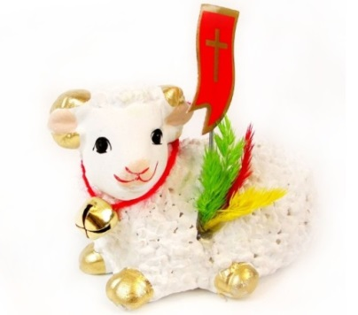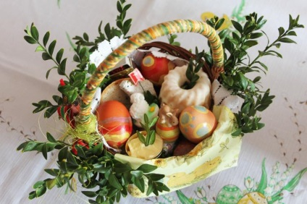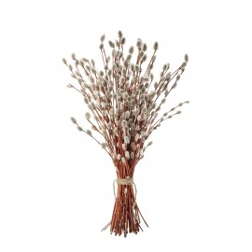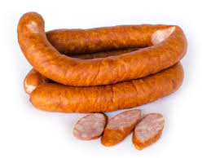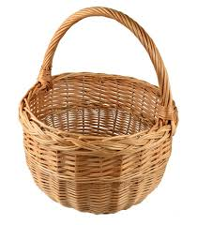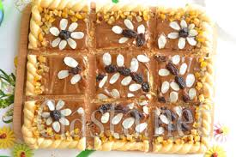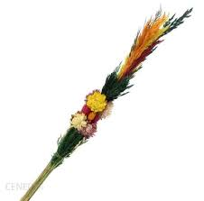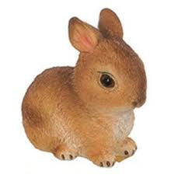

9

7

4

3

8

5

2

1

6

|  |  |  |  |  |  |  |  |  |  |  |  |  |  |  |  |  |
| --- | --- | --- | --- | --- | --- | --- | --- | --- | --- | --- | --- | --- | --- | --- | --- | --- |
| **UZUPEŁNIJ KRZYŻÓWKĘ**  ODCZYTAJ HASŁO | | | | | | 1 | | Ś | W | I | Ę | C | O | N | K | A |
|  | | | 2 | | B | A | | Z | I | E |  | | | | | |
| 3 | M | | | | A | Z | U | | R | E | K |
|  | | | | | 4 | P | | A | L | M | A |  | | | | |
|  | | 5 | K | I | E | Ł | B | A | S | A |
| 6 | | B | A | R | A | N | E | K |  | |
| 7 | | | P | I | S | | A | N | K | I |  | | |
|  | | | 8 | K | O | S | Z | Y | K |  | | |
| 9 | | Z | A | J | | Ą | C | Z | E | K |